|  |
| --- |
|  |
| Principles in Health Command - Course Booklet |
|  |
| Version 2, 10 February 2023 |

|  |
| --- |
| Classification: Official |
|  |

Contents

1. Introduction 3

1.1 Related Documents 3

1.2 Standards for Commanders 4

2. Legal foundations of EPRR 4

2.1 Core legislation and non-statutory guidance 4

3. Integrated Emergency Management and Risk 8

3.1 Risk Registers 8

3.2 Risk Perception 8

4. Core Concepts of Command, Control, Coordination & Communication 9

4.1 The 4 Cs 9

4.2 Tiers of Command 10

5. Responding to Emergencies 12

5.1 Incident / Emergency Terms & Definitions 12

5.2 Incident Levels 13

5.3 Notifications and cascades 13

5.4 JESIP 14

6. Defensible Decision Making and recording 22

6.1 Defensible decision making 22

6.2 Recording and Logging 23

7. Managing the Incident 23

7.1 Incident response structure and organisational roles 23

7.2 Incident Management Team (IMT) 27

7.3 Incident Coordination Centres (ICC) 28

7.4 Span of Control 28

7.5 Staff Welfare 30

7.6 Learning from Incidents – considerations when managing a team in an incident 31

8. Strategy 33

9. Debriefing and Inquiries 34

9.1 Debriefs 34

9.2 Reporting, Learning and embedding 34

9.3 Inquiries 35

Annex 1 Glossary of Terms – Common Terms 36

Annex 2 Minimum Occupational Standard – Respond to incidents and emergencies at the Strategic level 37

Annex 3 IIMARCH Template 38

Annex 4 JESIP Strategic Command Role and Responsibilities. 39

Annex 5 Examples of Multi-Agency Strategies from incidents 40

1. Introduction

The NHS strives to provide the best possible care to its patients even in the face of a range of challenges. Giving NHS managers the confidence and skills to lead the NHS during these challenges is a key part of the Emergency Preparedness Resilience and Response (EPRR) agenda.

This document draws together key learning from across the NHS and partners from a range of civil protection organisations. NHS Commanders should us this information as both a training aid and reference material during the preparation for, and the response to, incidents.

This booklet aims to both summarise and add to the information imparted to you as part of the Principles in Health Command training package. You can refer to this booklet to refresh and support the knowledge you have gained throughout the programme. The booklet also offers details on where to access further resources.

The Principles in Health Command programme aims to support the development of your knowledge and competencies as an effective strategic leader operating in several different environments, including multi-agency Strategic Coordinating Groups, Regional, System and Organisational Strategic Groups and Incident Management Teams.

**Aim**: to provide you and prospective strategic leaders with the ***principles of health command*** when leading / coordinating the strategic response to incidents and emergencies in those settings appropriate to your role and organisation.

Learning Objectives:

* Describe the core legal drivers underpinning Emergency Preparedness, Resilience and Response (EPRR)
* Examine EPRR concepts and terms
* Describe internal and external command, control and coordination requirements to support the response
* Examine the importance of situational awareness
* Explain the purpose of an Incident Management Team
* Describe internal and external communications requirements
* Develop a strategy to support and direct your response
* Outline recovery and learning activities
  1. Related Documents

Local plans and guidance should always be considered alongside the principles in this document.

This guidance should be read in conjunction with:

* [NHS EPRR Framework](https://www.england.nhs.uk/publication/nhs-emergency-preparedness-resilience-and-response-framework/)
* Organisational Major Incident or Incident Response Plan
* [NHS England Incident Response Plan](https://www.england.nhs.uk/publication/nhs-england-incident-response-plan-national/)
* [Joint Emergency Services Interoperability Principles (JESIP) Joint Doctrine](https://www.jesip.org.uk/downloads/joint-doctrine-guide/)

Further suggested reading and references can be found throughout the handbook.

* 1. Standards for Commanders

NHS England published a set of [Minimum Occupational Standards](https://www.england.nhs.uk/publication/minimum-occupational-standards-for-emergency-preparedness-resilience-and-response-eprr/) to support those who take command roles when responding to incidents in the NHS. These are a reviewed and condensed version of National Occupational Standards for Civil Contingencies, where the are multiple. Applicable NOS can also be found within the Minimum Occupational Standards document

In your role you may be required to operate in a multitude of environments and levels including, but not limited to:

* Organisation – Incident Director or a senior role within an Incident Management Team
* System – System Health Gold Chair or a senior role attending on behalf of your organisation/speciality
* Regional – Regional Health Gold Chair or a senior role attending on behalf of your system/speciality
* Multi agency (LRF) – Senior role attending a Strategic Coordinating Group on behalf of your system/speciality
* Response Coordinating Group (Region) - Senior role attending a Response Coordinating Group on behalf of your sector/discipline.
* Government meetings (Region and National) - Senior role attending a meeting with Government departments on behalf of your sector/discipline.

|  |
| --- |
| **Further sources of information**:   * Annex 2: Minimum Occupational Standards – Respond to incidents and emergencies at the Strategic level   <https://www.england.nhs.uk/publication/minimum-occupational-standards-for-emergency-preparedness-resilience-and-response-eprr/> |

1. Legal foundations of EPRR
   1. Core legislation and non-statutory guidance
      1. Civil Contingencies Act (2004) (CCA):

The CCA was created after the previous legislation, the Emergency Powers Act (1947) and Civil Defence Act (1948), was deemed unsuitable in response to several incidents across the UK.

The Act has two Parts. Part 1 of The Act categorises responders into two broad families. Category 1 (Core Responders) and Category 2 (Co-operating Bodies). The Act's Contingency Planning Regulations (2005) details a set of duties that each group of responders must perform.

Part 2 of The Act details the emergency powers that can be taken by the UK Government and Ministers. The Act establishes responsibilities for Category 1 and Category 2 responders.

**Category 1- Front line and first responders (Core responders)**

* Assess the risk of emergencies - Identify potential emergencies or incidents and their effects, then put plans into place to mitigate the effects or avoid it all together
* Undertake Business Continuity Management (BCM) - create methods to ensure a swift return to business as usual
* Plan for emergencies - Develop planned strategies that will mitigate the effects of an incident
* Warn, inform and advise the public - Share information relevant to the public to raise awareness of actions before, during and after an incident
* Promote BCM (Local Authorities Only) - Smaller businesses and organisations will not have the resources and expertise of larger organisations
* Co-operate - Through the Local Resilience Forum (LRF), category 1 and 2 responders establish best practice and common principles of action (JESIP)
* Share Information - All relevant information that can support all responders must be shared to ensure a coherent and coordinated response.

**Category 2- Supporting agencies unlikely to be in the initial response (Co-operating responders)**

* Co-operate - Alongside category 1 responders where relevant and necessary
* Share information - Information is likely to be key in establishing a coordinated and coherent response.
  + 1. Emergency Preparedness: Guidance to the CCA 2004 (legally considered statutory guidance)

Emergency preparedness sets out the generic framework for civil protection. This document predominantly covers the pre-emergency elements- anticipation, assessment, prevention and preparation. As such it adds detail to the legislation and gives good practice guidance on how Category 1 and Category 2 responders should carry out their duties to comply with the CCA.

Emergency Preparedness also gives further guidance on Integrated Emergency Management (IEM) which compromises of six related activities: anticipation, assessment, prevention, preparation, response and recovery. Effectively IEM breaks risk assessment and risk management down into stages. This creates a common approach and supports a shared understanding of multi-agency response and recovery arrangements across all categories of responders.

* + 1. Emergency Response and Recovery: Guidance to the CCA 2004 (legally considered non-statutory guidance)

Emergency Response and Recovery aims to develop multi-agency understanding and a common framework. You could see this as a horizontal integration of emergency response and recovery. It also aims to develop a shared understanding of the local, sub-national and national levels of emergency response and how they work together. This can be seen as the vertical integration of emergency response.  
  
Key elements include:

* Establishing good practice based on lessons identified
* Guidance on how to implement the Civil Contingencies Act
* Guidance on risk assessment, emergency, and business continuity planning, communicating with the public, co-ordination, information sharing and for local authorities only, business continuity promotion
* A shared understanding of the multi-agency framework for emergency response and recovery at the local level, and the roles and responsibilities of individual organisations
* A shared understanding of the role of local and national levels in emergency response, and how they will work together
* A common frame of reference, especially concepts and language.
  + 1. NHS England Emergency Preparedness, Resilience and Response Framework (legally considered statutory guidance)

The purpose of this document is to provide the framework for all NHS funded organisations in England to help with meeting the requirements of the Civil Contingencies Act 2004 (CCA 2004), the NHS Act 2006 as amended by the Health and Social Care Act 2012 (NHS Act 2006 (as amended)) and the NHS Standard Contract. This document seeks to describe how the NHS in England will go about its duty to be properly prepared for dealing with emergencies.

* + 1. Health and Social Care Act (2012)

The aim of the Health and Social Care Act is to put clinicians at the center of commissioning, free up providers to innovate, empower patients and give a new focus to public health. It gave rise to the establishment of Clinical Commissioning Groups, Healthwatch, Health and wellbeing Boards and paved the way for Public Health England. It also places a requirement on NHS organisations to be properly prepared to respond to emergencies.

* + 1. Health and Care Act (2022)

The health and care act of 2022, amongst other aspects of healthcare reform, created and formalised Integrated Care Boards (ICBs). Under The Act, ICBs were given the designation as a category 1 responder under the CCA (as amended).

* + 1. Health and Safety at Work Act (1974)

The Health and Safety at Work Act (1974) protects workers by properly controlling the risks to their health and safety are properly controlled. It lays out certain duties to the employer and the employee including:

* Securing the health, safety and welfare of persons at work
* Managing and controlling risks
* Providing information and training
* Controlling dangerous substances, certain emissions, and noise levels
* Employment medical advisory service.
  + 1. Corporate Manslaughter Act (2007)

The Corporate Manslaughter Act 2007 created an offence of corporate manslaughter which can be committed by organisations which cause the death of a person through gross negligence management failings. The offence of Corporate Manslaughter relates to the way in which the relevant activity was managed or organised throughout the company or organisation. Wider considerations such as the overall management of health and safety, the selection and training of staff, the implementation of systems of working and the supervision of staff can be taken into account.

An organisation is not liable if the failings were exclusively at a junior level. The failings of senior management must have formed a substantial element in the breach. However, the failings at senior management level do not of themselves have to amount to a gross breach of duty. Liability for the offence is assessed by looking at the failings of the organisation as a whole.

Prosecutions will be of the corporate body and not individuals, but the liability of directors, board members or other individuals under health and safety law or general criminal law, will be unaffected.

* + 1. Human Rights Act (1998)

The Human Rights Act 1998 sets out the fundamental rights and freedoms that everyone in the UK is entitled to. It incorporates the rights set out in the European Convention on Human Rights (ECHR) into domestic British law and includes:

* Right to life
* Right to respect for private and family life
* Right to freedom of religion and belief.
* Protection from discrimination

Public authorities, like a local authority or the NHS, must follow the Act.

|  |
| --- |
| **Further sources of information**:   * Civil Contingencies Act 2004   <https://www.legislation.gov.uk/ukpga/2004/36/contents>   * Emergency Preparedness – Statutory guidance (CCA 2004)   <https://www.gov.uk/government/publications/emergency-preparedness>   * Emergency Response and Recovery – Non statutory guidance (CCA 2004)   <https://www.gov.uk/government/publications/emergency-response-and-recovery>   * NHS England EPRR Framework & Guidance   <https://www.england.nhs.uk/ourwork/eprr/gf/#eprr>   * Health and Social Care Act 2012   <https://www.legislation.gov.uk/ukpga/2022/31/contents>   * Health and Social Care Act 2012   <https://www.legislation.gov.uk/ukpga/2012/7/contents>   * The role of Local Resilience Forums: A reference document   <https://assets.publishing.service.gov.uk/government/uploads/system/uploads/attachment_data/file/62277/The_role_of_Local_Resilience_Forums-_A_reference_document_v2_July_2013.pdf>   * Corporate Manslaughter Act 2007 <https://www.hse.gov.uk/corpmanslaughter/index.htm> * Human Rights Act 1998 <https://www.legislation.gov.uk/ukpga/1998/42/contents> |

1. Integrated Emergency Management and Risk
   1. Risk Registers

The National Risk Register (NRR) provides a public view of government’s assessment of the likelihood and potential impact of a range of different malicious and non-malicious national security risks (including natural hazards, industrial accidents, malicious attacks, and others) that may directly affect the UK and its interests. It also sets out how the UK Government and local responders manage these emergencies.

The NRR is particularly useful to local emergency planners, resilience professionals and organisations, helping them to make decisions about which risks planning for and what the consequences of these risks are likely to be. For example, the highest impact risks are Pandemics and large scale CBRN attacks.

As well as using the National Risk Register, organisations can also find information about risks to their local area through their Community Risk Register.

|  |
| --- |
| **Further sources of information**:   * National Risk Register 2020 [CCS's National Risk Register 2020 (publishing.service.gov.uk)](https://assets.publishing.service.gov.uk/government/uploads/system/uploads/attachment_data/file/952959/6.6920_CO_CCS_s_National_Risk_Register_2020_11-1-21-FINAL.pdf) |

* 1. Risk Perception

How people behave in an emergency depends on their understanding and appraisal of present risk exposure and of risk mitigation measures. What "risk" means to them, and what steers their assessment of a risk situation is therefore an essential matter. In most contexts the notion "risk" stands for a danger of unwanted and unfortunate events, not just uncertainty about the potential outcomes of an incident.

Risk perception refers to people's judgments and evaluations of hazards they (or their facilities, or environments) are or might be exposed to.

Such perceptions steer decisions about the acceptability of risks and are a core influence on behaviours before, during and after an emergency. People's risk appraisals are a complex result of hazard features and personal philosophies.

Every human is occupied with risk perception most of the time, whether driving a car or thinking about patient safety or worrying about fires in an environment and so on. Most people have views about every risk, regardless of whether they are exposed to it or not.

Risk perceptions steer decisions about the acceptability of risks and are a core influence on

behaviours before, during and after an incident or emergency. People's risk appraisals are a complex result of hazard features and personal philosophies, and the diagram below (source Rohrmann 1998) identifies the multitude of influences which affect responses to risk exposure.

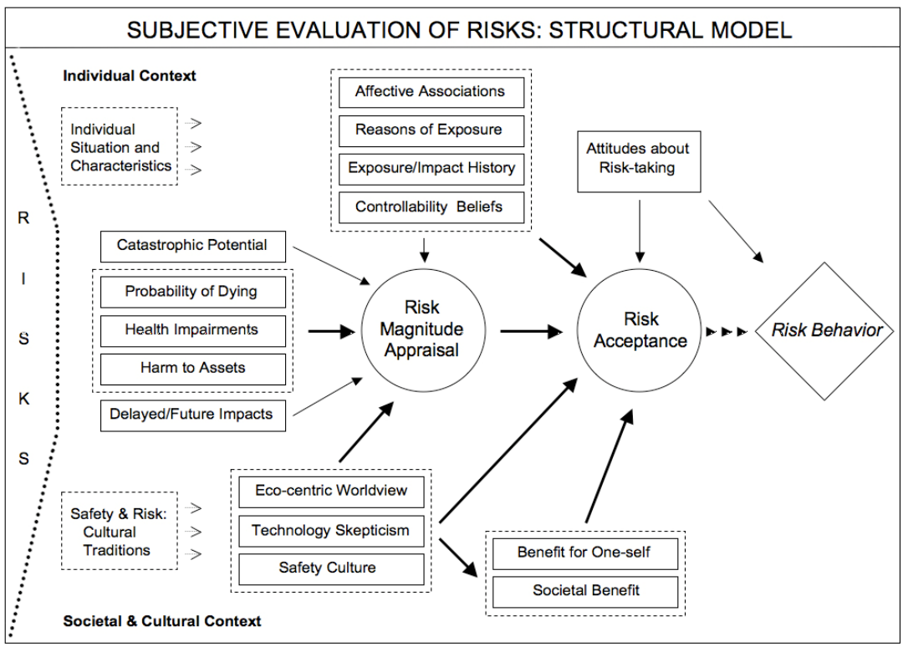

1. Core Concepts of Command, Control, Coordination & Communication
   1. The 4 Cs

Command and control can be referred to as C2. It will occasionally be termed C3 or C4 including coordination and communication respectively.

* + 1. Command

Command is the exercise of vested authority which is associated with a role or rank within an organisation to give direction to achieve defined objectives.

Command is carried out by those who have been given authority (through role or rank) over others, for a specific operation or incident, to make decisions and give direction to achieve jointly defined and agreed objectives. Individuals who provide subject matter expertise or advice, do so in support of the commanders and as part of the Command Support Team.

* + 1. Control

Control is the application of authority, combined with the capability to manage resources to achieve defined objectives.

Control is defined as the authority and capability of an organisation to direct the actions of its own employees. While one organisation cannot exercise command over another, it may be appropriate for commanders to grant the authority to exercise control of their organisation’s staff or assets to a coordinating group or commander of the designated lead organisation for a specific task.

* + 1. Coordination

Coordination is the integration of multi-agency efforts and available capabilities, which may be interdependent, to achieve defined objectives. The coordination function will be exercised through control arrangements, and requires that command of individual organisations’ personnel and assets is appropriately exercised in pursuit of the defined objectives

* + 1. Communication

Communication is the consideration of sharing and disseminating information to support the response. Typically, communications are supported by organisational communication functions in the formal sense, however commanders must ensure they are communicating effectively also. Communication is considered to be the ‘gel’ that enables command, control and coordination to function independently and together. It is often the aspect that is lacking when reviewing incidents.

* 1. Tiers of Command

The management of emergency response and recovery is undertaken at one or more of three ascending levels: Operational, Tactical and Strategic. The levels are defined by their differing functions rather than specific rank, grade or status.

* + 1. Strategic

The purpose of the strategic level is to consider the incident in its wider context; determine

longer-term and wider impacts and risks with strategic implications; define and

communicate the overarching strategy and objectives for the response; establish the

framework, policy and parameters for lower-level tiers; and monitor the context, risks,

impacts and progress towards defined objectives.

Where an event or situation has a particularly significant impact, substantial resource

implications, or lasts for an extended duration it may be necessary to convene a multi-agency coordinating group at the strategic level bringing together the strategic commanders

from relevant organisations. This group is known as the Strategic Coordinating Group (SCG).

The SCG does not have the collective authority to issue commands to individual responder

agencies: each will retain its own command authority, defined responsibilities and will

exercise control of its own operations in the normal way. The NHS strategic commander at

the SCG will be identified and agreed by NHS England in consultation with the ICB(s) and

empowered to make executive decisions on behalf of the NHS. In addition, the NHS

ambulance service(s) will be present in their role as an emergency service.

The purpose of the SCG is to take overall responsibility for the multi-agency management of

the incident and to establish the policy and strategic framework within which lower tier

command and coordinating groups will work. The SCG will:

* Determine and promulgate a clear strategic aim and objectives and review them regularly
* Establish a policy framework for the overall management of the event or situation
* Prioritise the requirements of the tactical tier and allocate personnel and resources accordingly
* Formulate and implement media-handling and public communication plans
* Direct planning and operations beyond the immediate response in order to facilitate the recovery process

For incidents across multiple SCG areas then NHS England regional and national teams, as

appropriate, will undertake command, control and coordination of the NHS and will be

responsible for appropriate representation to regional and central coordination structures

and groups.

* + 1. Tactical

The purpose of the tactical level is to ensure that the actions taken by the operational level are coordinated, coherent and integrated in order to achieve maximum effectiveness, efficiency and desired outcomes.

Where formal coordination is required at tactical level then a Tactical Coordinating Group (TCG) may be convened with multi-agency partners within the area of operations. The tactical commanders will:

* Determine priorities for allocating available resources
* Plan and coordinate how and when tasks will be undertaken
* Obtain additional resources if required
* Assess significant risks and use this to inform tasking of operational commanders
* Ensure the health and safety of the public and personnel.

The tactical commanders must ensure that the operational commanders have the means,

direction and coordination to deliver successful outcomes.

The NHS tactical commander at the TCG will be identified and agreed by NHS England in

consultation with the ICB. They will ensure that all NHS service providers are coordinated

through health economy tactical coordination groups.

Where it becomes clear that resources, expertise or coordination are required beyond the

capacity of the tactical level it may be necessary to invoke the strategic level of

management to take overall command and set the strategic direction

* + 1. Operational

Operational is the level at which the management of immediate ‘hands on’ work is undertaken. Operational commanders will concentrate their effort and resources on the specific tasks within their geographical or functional area of responsibility.

Individual organisations retain command authority over their own resources and personnel, but each organisation must liaise and coordinate with all other organisations involved, ensuring a coherent and integrated effort. This may require the temporary transfer of personnel or assets under the control of another organisation.

These arrangements will usually be able to deal with most events or situations but if greater planning, coordination or resources are required an additional tier of management may be necessary. The operational commander will consider whether a tactical level is required and advise accordingly.

1. Responding to Emergencies
   1. Incident / Emergency Terms & Definitions

Incidents are classified to support the planning (e.g., who is responsible for coordinating, what resources are required etc), response and recovery from incidents that manifest from a range of hazards and threats.

For the NHS, incidents are classed as either:

* Business Continuity Incident
* Critical Incident
* Major Incident

Each will impact upon service delivery within the NHS, may undermine public confidence

and require contingency plans to be implemented. NHS organisations should be confident

of the severity of any incident that may warrant a major incident declaration, particularly

where this may be due to internal capacity pressures, if a critical incident has not been

raised previously through the appropriate local escalation procedure.

* + 1. Business Continuity Incident

A business continuity incident is an event or occurrence that disrupts, or might disrupt, an

organisation’s normal service delivery, below acceptable predefined levels, where special

arrangements are required to be implemented until services can return to an acceptable

level. (This could be a surge in demand requiring resources to be temporarily redeployed)

* + 1. Critical Incident

A critical incident is any localised incident where the level of disruption results in the

organisation temporarily or permanently losing its ability to deliver critical services, patients

may have been harmed or the environment is not safe requiring special measures and

support from other agencies, to restore normal operating functions.

* + 1. Major Incident

A major incident is any occurrence that presents serious threat to the health of the community or causes such numbers or types of casualties, as to require special arrangements to be implemented.

* 1. Incident Levels

As an event evolves it may be described in terms of its level as shown. For clarity these

levels must be used by all organisations across the NHS when referring to incidents.

|  |  |
| --- | --- |
| **Level 1** | An incident that can be responded to and managed by an NHS-funded organisation within its respective business as usual capabilities and business continuity plans |
| **Level 2** | An incident that requires the response of a number of NHS-funded organisations within an ICS and NHS coordination by the ICB in liaison with the relevant NHS England Region |
| **Level 3** | An incident that requires a number of NHS-funded organisations within an NHS England region to respond. NHS England to coordinate the NHS response in collaboration with the ICB.  Support may be provided by the NHS England Incident Management Team (National) |
| **Level 4** | An incident that requires NHS England national command and control to lead the NHS response.  NHS England Incident Management Team (National) to coordinate the NHS response at the strategic level.  NHS England (Region) to coordinate the NHS response, in collaboration with the ICB, at the tactical level. |

|  |
| --- |
| **Further sources of information**:  NHS England EPRR Framework: <https://www.england.nhs.uk/ourwork/eprr/> |

* 1. Notifications and cascades

While emergencies are often triggered by ‘big bang’ events and alerts are cascaded by NHS ambulance services, there are other potential circumstances where an NHS incident occurs, for example infectious disease outbreaks. In such cases the ambulance service may or may not be involved and may not be the alerting mechanism for the health sector.

In the event of such an incident the communication cascade mechanism should be via local commissioners who should ensure they also alert their Regional NHS England (NHSE) Team. In some instances, such alerts may also come directly from NHSE National.

The Regional NHSE Team will assist ICBs in implementing command and control mechanisms and the deployment of appropriate NHS resources should the response extend beyond the operational area of a single ICB.

Health services should always use standard alerting messages:



* 1. JESIP

JESIP provides incident and emergency commanders/coordinators, at the scene and elsewhere, with generic guidance on the actions they should take when responding to multi-agency incidents of any scale. It is built on common principles for consistent terminology and ways of working. JESIP should be embedded in individual organisation policies and procedures and in training and exercise programmes, for all levels of response staff.

* + 1. Principles for Joint Working

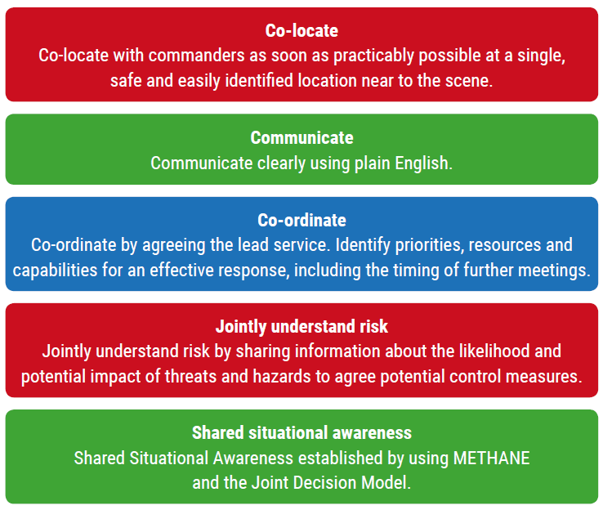

* + 1. Joint Decision Model (JDM)

|  |  |
| --- | --- |
|  | One of the difficulties facing incident commanders/coordinators from different agencies is how to bring together the available information, reconcile potentially differing priorities and then make effective decisions together.  The Joint Decision Model (JDM), shown below, was developed to resolve this issue.  All joint decisions, and the rationale behind them, should be recorded in a ‘joint decision log’  Responding agencies should work together to build shared situational awareness, recognising that this requires continuous effort as the situation, and responders’ understanding, will change over time. |

* **Working Together – Saving Lives, Reducing Harm**

The pentagon at the centre of the joint decision model reminds commanders/coordinators that all joint decisions should be made with reference to the overarching or primary aim of any response to an emergency – to save lives and reduce harm.

This should be the most important consideration, throughout the decision-making process.

* **Gather Information and intelligence**

This stage involves gathering and sharing information and intelligence to establish shared situational awareness.

At any incident, no single responder agency can appreciate all the relevant dimensions of an emergency straight away.

A deeper and wider understanding will only come from meaningful communication between the emergency services and other responder agencies. Commanders/ Coordinators cannot assume others will see things, or say things, in the same way.

There may need to be a sustained effort to reach a common view and understanding of events, risks and their implications,

Decision making in the context of an emergency, including decisions on sharing information, does not remove the statutory obligations of agencies or individuals, but it is recognised that such decisions are made with an overriding priority of saving lives and reducing harm.

Personal data, including sensitive personal data (such as patient information), must be carefully considered before it is shared across agencies. The joint decision model can be used as a tool to guide decision making on what information to release, and who can receive it.

M/ETHANE is a structured and consistent method for responder agencies to collate and pass on information about an incident.

The METHANE model is an established reporting framework which provides a common structure for responders and their control rooms/ Incident Coordination Centres to share major incident information.

**For incidents falling below the major incident threshold ‘METHANE’ becomes an ‘ETHANE’ message.**

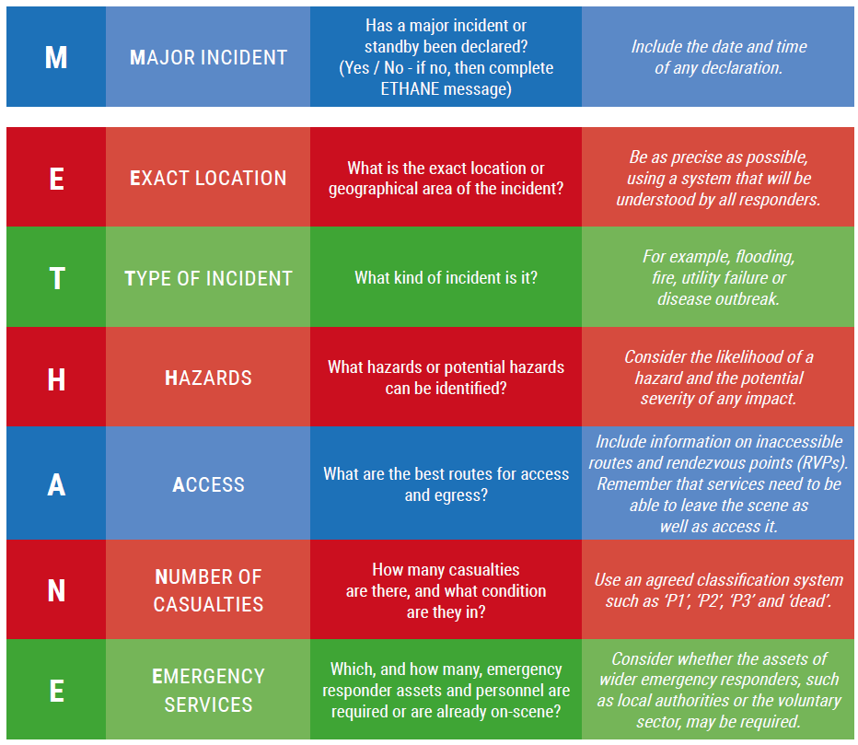

* **Assess risks, develop a working strategy**

Commanders/Coordinators jointly assess risk to achieve a common understanding of threats and hazards, and the likelihood of them being realised. This informs decisions on deployments and the required risk control measures.

A key task for commanders/coordinators is to build and maintain a common understanding of the full range of risks. They should consider how risks may increase, reduce or be controlled by any decisions made and subsequent actions taken. At any incident, each agency will have a unique insight into those risks.

By sharing what they know commanders/coordinators can establish a common understanding. Commanders/coordinators can then make informed decisions on deployments and the risk control measures required. Time critical tasks should not be delayed by this process.

The risk control measures to be employed by individual services must also be understood by other responder agencies, to ensure any potential unintended consequences are identified before activity commences. This increases the operational effectiveness and efficiency of the response as well as the probability of a successful incident resolution.

The working strategy should not be confused with the strategy for the incident provided by the strategic commanders or strategic co-ordinating group. This strategy will generally be issued some time into the incident response and almost certainly after the operational or tactical levels of command have been established.

The working strategy is the action plan that commanders develop and agree together. They put the action plan in place to address the immediate situation and the risks that they are faced with to save lives and reduce harm.

It is rare for a complete or perfect picture to exist for a rapid onset incident. The working strategy should therefore be based on the information available at the time.

When developing a working strategy, consider:

* + Sharing single service risk assessments
  + Recording and agreeing the joint assessment of risk, in an agreed format

When developing a working strategy, commanders should consider these questions:

* + **What**: Are the aims and objectives?
  + **Who by**: Police, fire and rescue services, the ambulance service, Acute Trust, Community/Mental Health Provider, ICB and other organisations?
  + **When**: Timescales, deadlines and milestones?
  + **Where**: What locations?
  + **Why**: What is the rationale? Is it consistent with the overall strategic aims and objectives?
  + **How**: Will these tasks be achieved?

For an effective integrated multi-agency operational response plan, objectives and priorities must be agreed jointly. Each agency will then prioritise their plans and activity.

The following key steps should be undertaken:

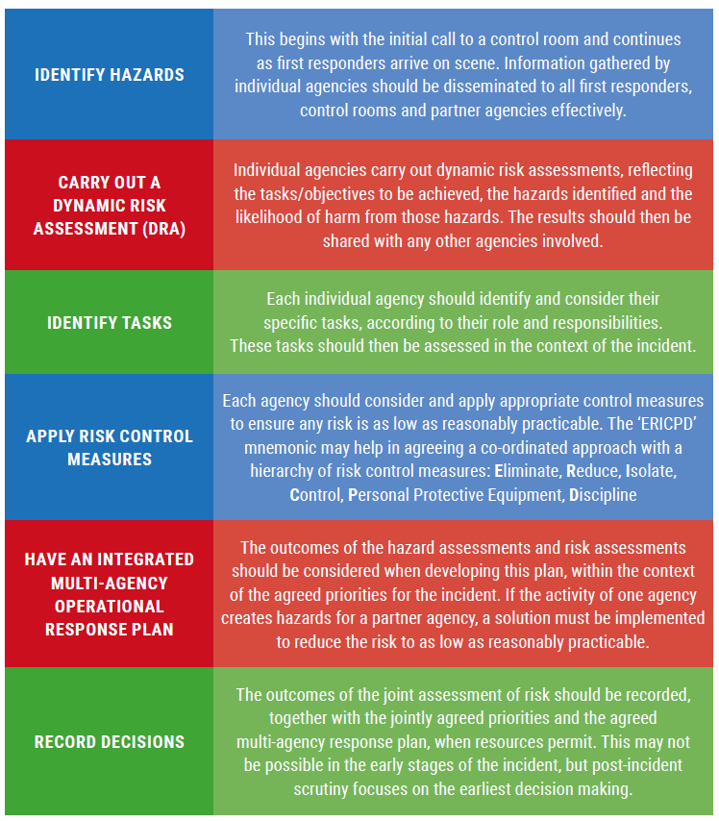

* **Consider Powers, Policies and Procedures**

This stage relates to any relevant laws, procedures or policies that may impact on the response plan and the capabilities available to be deployed.

Decision making in an emergency will focus on achieving the desired end state. Various constraints and considerations will shape how this is achieved.

Power, policies and procedures may affect how individual agencies operate and co-operate to achieve the agreed aims and objectives.

In a joint response, a common understanding of any relevant powers, policies, capabilities and procedures is essential so that the activities of one responder agency complement rather than compromise the approach of other responder agencies.

* **Identify Options and contingencies**

There will almost always be more than one way to achieve the desired end state. Commanders should work together to evaluate the range of options and contingencies rigorously.

Potential options or courses of action should be evaluated, considering:

* + **Suitability** Does it fit with the strategic direction?
  + **Feasibility** Can it be done with the available resources?
  + **Acceptability** Is it legal, morally defensible and justifiable?

Whichever options are chosen, it is essential that commanders/coordinators are clear on what they need to carry out. Procedures for communicating any decision to defer, abort or initiate a specific tactic should also be clearly agreed.

Contingencies relate to events that may occur and the arrangements that will be put in place if they do occur. For example, strong evidence may suggest that an emergency is being successfully managed and the impacts safely controlled, but there remains a likelihood that the situation could deteriorate and have a significant impact. It is not good enough to ‘hope for the best’ and a contingency may include defining the measures to be taken if the situation deteriorates.

* **Decision Controls**

As part of the decision-making process, decision makers should use decision controls to ensure that the proposed action is the most appropriate.

Decision controls support and validate the decision-making process. They encourage reflection and set out a series of points to consider before making a decision. Note that points (a) to (d) are intended to structure a joint consideration of the issues, with (e) suggesting some considerations for individual reflection.

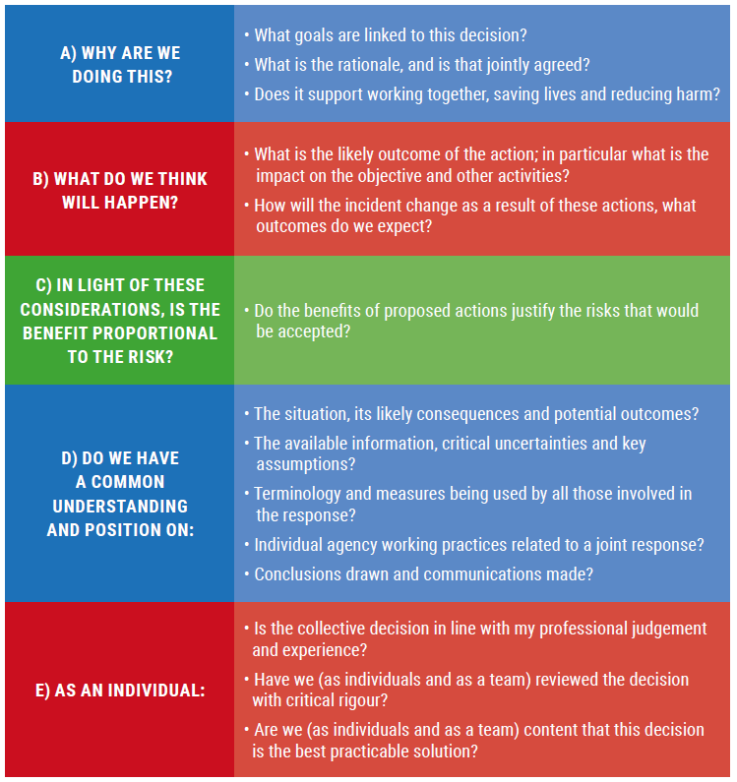

Once the decision makers are satisfied, collectively and individually, that the decision controls validate the proposed actions, then these actions should be implemented.

* **Briefing**

Once commanders/coordinators have made decisions and decided on actions, information must be relayed in a structured way that can be easily understood by those who will carry out actions or support activities. This is commonly known as briefing.

IIMARCH: In the initial phases of an incident, the joint decision model may be used to structure a briefing. As incidents develop past the initial phases or if they are protracted and require a hand over between commanders and responders, then a more detailed briefing tool should be used. The mnemonic ‘IIMARCH’ is a commonly used briefing tool (See Annex 3).

Using the IIMARCH headings shown below as a guide, information can be briefed in appropriate detail:

* + Information
  + Intent
  + Method
  + Administration
  + Risk assessment
  + Communications
  + Humanitarian issues

SBAR: Within Healthcare settings SBAR is a commonly used tool to support briefing – especially during ‘critical incidents’:

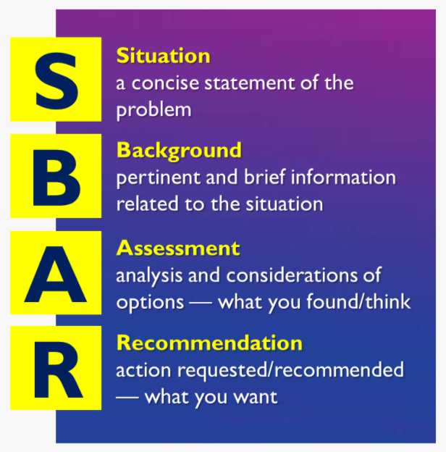

“SBAR is a structured method for communicating critical information that requires immediate attention and action contributing to effective escalation and increased patient safety” (NHS Institute for Innovation and Improvement).

* **Take action and review what happened**

Building shared situational awareness, setting direction, evaluating options and making decisions all lead to taking the actions that are judged to be the most effective and efficient in resolving an emergency and returning to a new normality.

Actions must be reviewed. As information changes during the response, commanders/ coordinators should use the joint decision model to inform their decision making until the incident is resolved.

|  |
| --- |
| **Further sources of information**:   * Joint Doctrine: The Interoperability Framework   <https://www.jesip.org.uk/uploads/media/pdf/Joint%20Doctrine/JESIP_Joint_Doctrine_Document.pdf>   * SBAR Guidance   <https://www.england.nhs.uk/wp-content/uploads/2015/11/eprr-framework.pdf>(Pg 29)  <https://www.england.nhs.uk/wp-content/uploads/2021/03/qsir-sbar-communication-tool.pdf> |

1. Defensible Decision Making and recording
   1. Defensible decision making

You may be called on to justify your decisions to audiences both within and external to your organisation. If so, a written or electronic record is more reliable than memory alone. The following elements, if present, are likely to make a decision defensible:

* all available information has been collected, recorded and thoroughly evaluated
* policies and procedures have been followed
* reliable assessment methods have been used where available
* all reasonable steps have been taken and any information acted on
* practitioners and their managers have communicated with each other and with other agencies, been effective and proactive, and have adopted an investigative approach
* decisions have been recorded (and subsequently carried out).

Consider your model for considering decisions, this will help frame your records.

|  |  |  |  |  |  |  |  |  |
| --- | --- | --- | --- | --- | --- | --- | --- | --- |
| **Further sources of information**:   |  |  | | --- | --- | | * PHE Decision Logs – Handout |  | | * PHE Evidence – Handout |  | | * PHE Best Practice – Handout |  | | * Inquiries and Investigations - Handout |  | |

* 1. Recording and Logging

NHS funded organisations must have appropriately trained and competent loggists to support the management of an incident. Loggists are an integral part in any incident management team. It is essential that all those tasked with logging do so to best practice standards and understand the importance of logs in the decision-making process, in evaluation and identifying lessons and as evidence for any subsequent inquiries.

Following an incident, a number of internal investigations or legal challenges may be made. These may include Coroners inquests, public inquiries, criminal investigations and civil action.

When planning for and responding to an incident it is essential that any decisions made, or actions taken are recorded and stored in a way that can be retrieved at a later date to provide evidence. It may be necessary to provide all documentation, therefore robust and auditable systems for documentation and decision making must be maintained.

The organisation’s Document Retention policies and procedures should cover the requirements of EPRR.

* + 1. Best Practice – No ELBOWS
* No **E**rasures
* No **L**eaves torn out
* No **B**lank Spaces
* No **O**verwriting
* No **W**riting between the lines
* **S**tatements in direct speech

1. Managing the Incident
   1. Incident response structure and organisational roles

The below figure taken from the NHS EPRR Framework (2022), provides an overview of the UK response structure from an NHS point of view. Detailed are outline roles and responsibilities of differing organisations and groups.

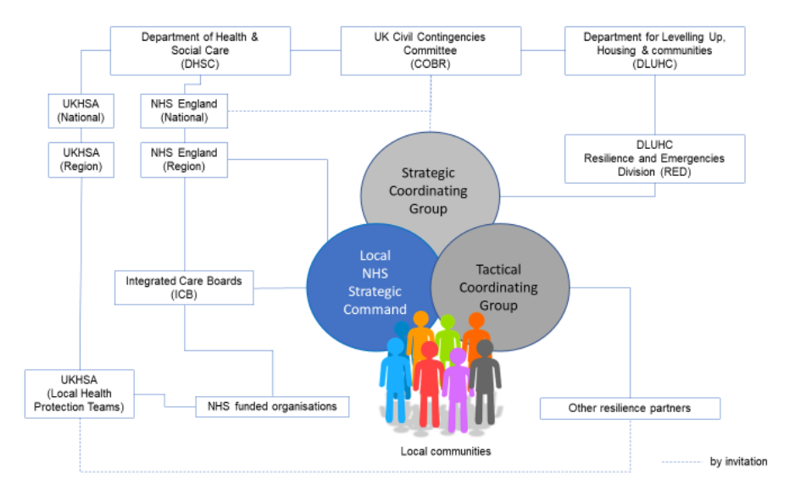

* + 1. Cabinet Office Briefing Room (COBR)

Responsible for coordinating the government's response to emergencies in the UK. It acts as a central hub for decision-making, information sharing, and communication during crisis situations.

Convening of Government Officials: COBR convenes key government officials, including ministers and senior officials from relevant departments, to provide them with information about the emergency, discuss the response, and make decisions about the government's response. This includes ensuring that all relevant departments are working together effectively, and that the government's response is coordinated, effective, and efficient.

* + 1. Department for Health and Social Care (DHSC)

Responsible for ensuring that the health and social care system is prepared for and can respond effectively to emergencies.

Policy Development and Implementation: The DHSC is also responsible for developing policies and strategies to prepare for and respond to emergencies, and for ensuring that these policies are implemented effectively. This includes working closely with other government departments and agencies, as well as with health and social care providers and other stakeholders, to ensure a coordinated and effective response to emergencies.

* + 1. Department for Levelling Up, Housing & Communities (DLUCH)

Responsible for working with local authorities and other stakeholders to develop and implement emergency plans and responses to crisis situations.

Support to Local Authorities: provides support to local authorities during emergencies, including financial assistance, guidance, and resources. This helps to ensure that local communities are able to respond effectively to emergencies, and that the impact of emergencies on communities is minimised. Also works closely with other government departments and agencies to ensure that the government's response to emergencies is coordinated and effective.

* + 1. NHS England

Responsible for ensuring that the NHS is prepared for and can respond effectively to emergencies. This includes ensuring that hospitals and other health care facilities have the resources and capacity they need to provide care during emergencies.

Coordination of Health Services: NHS England works closely with other parts of the health care system, including primary care providers, local authorities, public health and emergency services, to coordinate the health care response to emergencies. This includes ensuring that patients receive the care they need in a timely and effective manner, and that the health care system is able to cope with the increased demand for services that often occurs during emergencies.

* + 1. UK Health Security Agency (UKHSA)

Responsible for providing scientific and technical advice, guidance, and support to the government, health care providers, and the public. This includes conducting risk assessments, monitoring and tracking public health threats, and providing health protection guidance.

Surveillance, Risk Assessment, and Health Protection: UKHSA is responsible for gathering and analysing intelligence about public health emergencies, conducting risk assessments and providing advice on the management of public health risks, and protecting and improving the nation's health by providing guidance and support on health protection issues during emergencies.

* + 1. Integrated Care Boards

Responsible for coordinating and leading the Integrated Care System’s response, working with NHS England, commissioned services and other partners to ensure an appropriate response.

Additionally, will represent the local health economy at Strategic Coordinating Groups and Tactical Coordinating Groups as appropriate, in conjunction with NHS England as necessary. ICBs may also be required to commission additional services as required to support response and recovery, provide support to communities and vulnerable people, both during the incident, and afterwards through the recovery process.

* + 1. NHS Ambulance Services

Responsible for providing pre-hospital care and transportation for patients who have been affected in an incident. Activities include:

* Pre hospital triage and treatment
* Transportation to most appropriate hospital or care facility
* Managing the on scene NHS response
* In CBRN incidents deploy decontamination equipment and teams to the scene
* Deploy specialist assets including critical care and Hazardous Area Response Teams (HART).
  + 1. NHS Acute Providers

Responsible for providing hospital care and specialist services (as commissioned) for patients who have been affected in an incident. Activities include:

* Activate appropriate and proportionate plans to manage the situation whilst maintaining services
* Expand capacity
* Consider accelerated discharge.
* Mitigate impact of emergency by activating business continuity plans
* Provide on site decontamination and response to HazMat (Hazardous Materials) or CBRN (Chemical, Radiological, Biological & Nuclear) incidents.
  + 1. NHS Mental Health Services

Responsible for providing emergency mental health support during major incidents. They provide mental health assessments, treatment, and support for individuals who have been affected by a major incident, such as a large-scale disaster or a major terrorist attack. This is typically commissioned as part of the response.

* + 1. NHS Community Providers

Responsible for providing care and support to individuals and communities who have been affected. They work closely with other emergency services and agencies, including the police, fire and rescue services, and other health care providers, to coordinate their response and ensure that the needs of affected communities are met. Organisations may be asked to provide medical services for those who are taking shelter in a reception centre set up by a local authority.

* + 1. Strategic Co-ordinating Groups

Multi-Agency Coordination: Strategic Coordinating Groups (SCGs) are multi-agency groups that are established to coordinate the response to specific types of emergencies, such as major incidents or public health emergencies. They bring together representatives from government, local authorities, emergency services, NHS and other stakeholders to ensure that the response to an emergency is coordinated and effective. SCGs typically cover the footprint of a police authority.

Decisions and Recommendations: SCGs play a critical role in making decisions and providing recommendations on the local response to emergencies. They provide a forum for discussion and decision-making and ensure that all relevant agencies are working together effectively to respond to the emergency. This helps to ensure that the response is efficient, effective, and consistent with the overall strategic objectives.

* + 1. Tactical Co-ordinating Groups

On-Ground Coordination: Tactical Coordinating Groups (TCGs) are groups that are established to coordinate the response to specific emergencies at the local level. They bring together representatives from local authorities, emergency services, NHS and other stakeholders to ensure that the response to an emergency is coordinated and effective at the operational level.

Incident Management: TCGs play a key role in incident management, providing a coordinated response to the immediate needs of affected communities and ensuring that resources are deployed effectively. They work closely with other agencies, including SCGs, to ensure that the response to an emergency is consistent with the overall strategic objectives of the government and that the needs of affected communities are met.

Decision Making: TCGs make decisions on the deployment of resources, the allocation of tasks, and the implementation of response and recovery activities. They work to ensure that the response to an emergency is consistent with local plans and that the needs of affected communities are addressed effectively. The decisions made by TCGs are critical to ensuring that the response to an emergency is effective and that the impact of the emergency is minimised.

* + 1. Police Authorities
* Overall responsibility for coordinating the emergency response.
* Scene preservation and cordon control
* Take the lead when crime or terrorism suspected
* Specialist staff to lead investigation, victim recovery and victim identification through disaster victim identification (DVI).
* Establish casualty bureau to match missing persons information from public to hospital records via documentation teams
* Family liaison
* Represent Her Majesty’s Coroner.
  + 1. Fire Services
* Work with partner agencies to respond to incidents
* Key responses to firefighting, release of trapped casualties, rescue from heights and hazardous area
* Resources include ability to provide high volume pumps, urban search and rescue and mass decontamination.
* Ability to detect, monitor and identify hazardous substances at scene
* Safety management within the inner cordon.
  + 1. Local Authorities
* Social care and psychosocial support
* Reception centres
* Rehousing and accommodation
* Technical and engineering advice
  1. Incident Management Team (IMT)

The IMT for an organisation provides support to the Strategic Lead in directing and coordinating the response to an incident; made up of staff undertaking key functions. Depending on the type, nature, complexity and duration of an incident, may include:

* Communications
* Finance
* Logging
* Logistics
* Operations
* Planning
* Records management
* Reporting
* Specialist support e.g., EPRR, IPC
  1. Incident Coordination Centres (ICC)

The ICC supports the Incident Management Team (IMT) to provide an enhanced level of operational support. It is widely recognised that the efficiency and effectiveness of an ICC is greatly improved through the utilisation of a formal structure. Benefits of this include:

* Unity of effort – all team members operate under a common list of objectives
* Accountability – everyone has a specific role for which they are responsible
* Eliminates redundancy – clearly established division of labour eliminates duplication of effort

All organisations need to have in place suitable and sufficient arrangements to effectively manage the response to an incident. Arrangements for the ICC need to be flexible and scalable to cope with a range of incident scales and hours of operation required.

Each organisation needs the ability to establish an ICC and maintain a state of organisational readiness. Large organisations with multiple sites may need a facility at each location where tactical and operational functions can be coordinated supported by a separate strategic facility for overall command and control.

There should be sufficient resilience within the organisation to ensure that there is an alternative ICC available for use in the event the primary ICC is unavailable. An ICC must be resilient to loss of utilities, including telecommunications, and to external hazards such as flooding.

The ICC should have an activation plan with action cards for key staff working within it. Sufficient resources should be made available to coordinate an incident over an extended period.

ICC equipment should be tested every three months as a minimum to ensure functionality.

* 1. Span of Control

The volume and complexity of information being communicated can easily become overwhelming, especially in the early stages on an incident. One way to help to alleviate the issue is to ensure that spans of control do not become overcomplicated. Clear and tight spans of control reduce unnecessary chatter that overburdens commanders, especially at the tactical level. It is recommended that a span of control is limited to five or six lines of communication. The first figure below represents a structure where information and communications will be overloaded. Whilst it can be resource intensive, adding an extra layer to the command structure will help to reduce spans of control to a more manageable level. The second figure below shows a more appropriate structure.

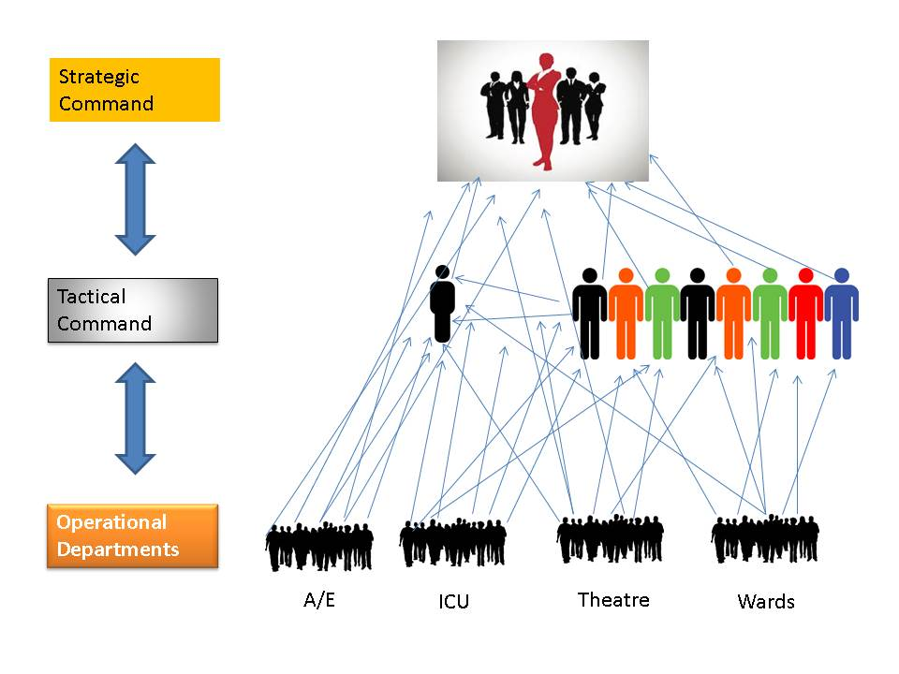

Overwhelming spans of control

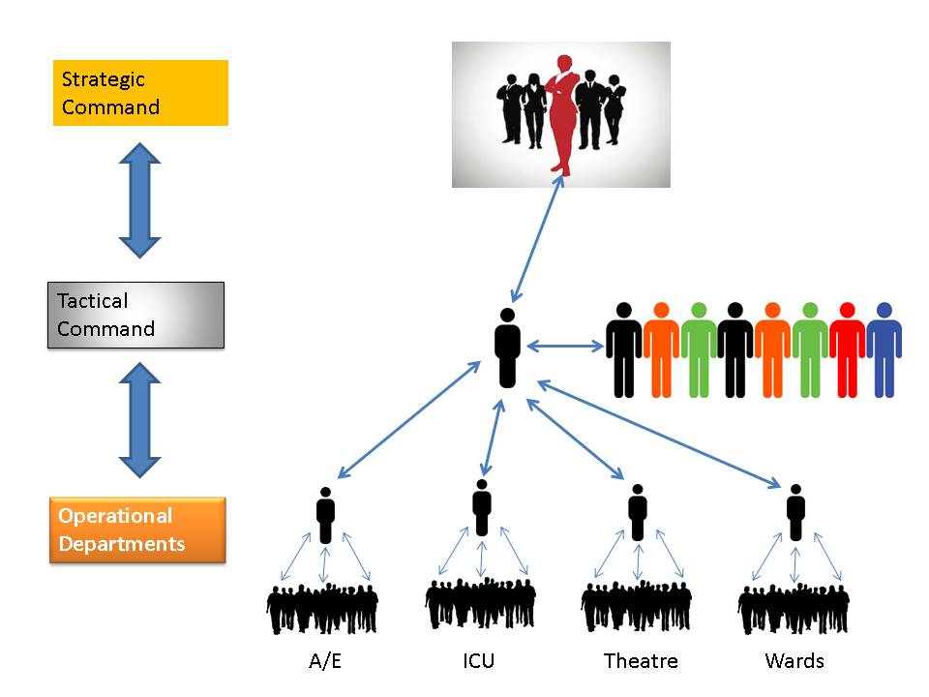

Appropriate spans of control

* 1. Staff Welfare

Incident management is very intensive and draining, and all key incident roles should be supported by separately appointed staff who are coordinating rotas and ensuring staff welfare needs are met, including regular breaks, and handovers to successor staff. Loggists should log for a maximum of 3 hours (less if the incident is intensive), and incident staff for a maximum of 6 hours where possible.

Incident Commanders should when possible, delegate staff welfare to another member of the incident team who is not otherwise directly involved in the incident response. This person should ensure that:

* Staff relief is planned to come in to take over in a timely way
* Staff are monitoring for stress
* A breakout area is provided
* Wider support is available if required, e.g. HR advice

Outside of an incident response, organisations need to ensure they have trained staff to fulfil each of the required roles outlined in their plan.

* 1. Learning from Incidents – considerations when managing a team in an incident
     1. Group Think

In an IMT or ICC decisions can get made by a group of individuals who might not often work together. Sometimes decisions get made by committee as the Incident Commander is inexperienced in command or does not feel able to make decisions.

The problem that can develop is known as ‘Group Think’. On some occasions the team can suspend rational judgement to maintain group cohesion. Team Members may set aside their reservations and opinions and adopt the opinion of the group leading to failure to challenge. This can be especially prevalent if a dominant team leader puts forward their view. People who are opposed might stay quiet to avoid conflict. However, this opinion might be crucial to the group’s decision.

* **Lack of Confidence** – Team members might lack the confidence to contribute new or relevant information.
* **Failure to challenge** – Team members may fail to challenge assumptions because they wrongly assume that others share the same understanding of the situation.
* **Status** – Incident commanders should avoid judging how relevant information is by the status of who is giving it. A team might give more weight to the opinions of the Chief Executive than another more junior member. Useful information may come from any member of the team.
* **Organisational Culture** – The culture of the NHS and providers might be affected by the organisational structures and layers, multiple commissioners and providers. There may also be a culture that drives decision-making high up in the organisation rather than with commanders. Emergency plans must be explicit on decision making authority.
* **Interpersonal conflict** – Any conflict between team members may cause lack of co-operation, trust and motivation.
  + 1. Effective Communication

Briefing and on-going communication within and between your response team is crucial in a response. We face barriers to effective communication in everyday life, but these barriers can be heightened in an emergency situation and it’s important to be aware of them, and the tools available to overcome them.

Barriers include:

* **Listener’s capacity/workload** – In a response we may be too busy responding to here what we are being told.
* **Stress** – stress plays a huge role in affecting communications from not thinking or communicating in a rationale manner through to selective hearing where we only hear what we want to.
* **Interruption** – This is particularly problematic in an Incident Coordination Centre where phone calls and people bringing messages in and out of the room can cause disruptions and interruptions to communications.
* **Voice, accent, tone, volume** – The way people communicate is just as important as the words they speak.
* **Culture, loss of face** – Some people may not want to speak up or feel uncomfortable doing so, it’s important to ensure there are no barriers to communication in the team and everyone feels they can contribute.

When communicating we need to think about the tools which can assist us (SBAR, IIMARCH) to ensure that communications follow a standard format, conveying all relevant information. One of the most effective tools we can use is **questioning**, and ensuring we ask the right questions in the right format. Developing our skills at posing the right questions, in the right way, at the right time, will help us ensure that we as individuals, and the team in which we are working, have the best level of information needed to protect us from error.

Question Types:

**Closed** Requires a factual or simple yes/no answers

**Open** Prompts a more extensive, unconstrained reply

**Limiting** Narrows response to either/or of given options

**Leading** Indicates the answer - beware confirmation bias

When you are asking a question – particularly to a busy person – it is very easy to lead them to an answer that agrees with your perception than to make them think it through themselves. It is always better to ask an open question in order that the person must go through the mental process of considering the response.

When communicating, another tool we should use is closed loop communication. Here a team member makes a request using the name of another team member, the team member being addressed responds verbally to confirm the action thus closing the loop.

* + 1. Assertiveness

When workload is high and everyone is working under stress, a situation may occur where a member of the team notices that an error is about to be made. How easy will it be to raise your concerns and prevent the mistake from happening? Several concerns may run through your/their mind: I’m not sure I’m right, I’m too junior, I don’t want to look stupid, I may be reprimanded. It is difficult!

Consider using tools like the pneumonic, PACE:

**P**ROBE Ask a question for a better understanding, to raise discomfort

**A**LERT Raise any anomalies, express discomfort objectively

**C**HALLENGE State concerns, use more formal language

**E**MERGENCY Make direct eye contact, use a Trigger Word like ‘must’, physically intervene if necessary.

**Managing Conflict** - remain ‘Adult’

* Respect the other person
* Keep an open mind
* Assume the other person has a valid point
* Focus on the facts and issues
* Don’t patronise
* Try for a ‘win-win’ solution.

1. Strategy

Setting a strategy often depends on both context (*the circumstances that form the setting for an event, statement, or idea, and in terms of which it can be fully understood and assessed*) and your role [e.g., strategic lead/ response role etc]. You may be responsible for overseeing the development of a strategy or for contributing to one.

Think about the settings you may find yourself in leading/supporting the response to emergencies e.g. [NHS specific] organisation (Level 1), System (Level 2), Regional (Level 3), National (Level 4), [non-NHS specific] Strategic Coordinating Group, Large Event (G7, Glastonbury) etc.

Strategies used in incidents previously can be found at Annex 5.

A working strategy may precede a response strategy to address the immediate needs of responding to an incident. Setting the strategy should be done in partnership using the principles of JESIP: Co-Locate, Communicate, Coordinate, Jointly Understand risk and Shared Situational Awareness.

**Being ‘S T R A T E G I C’ aide memoire**

**S** **Strategy** – what is the plan for now/the next few hours/days?

**T** **Tactical** – have you got all you need in place to achieve your objectives? Any gaps?

**R** **Resources** – do you have everything you need now an in the near future (people, assets, mutual aid)?

**A** **Anticipate** – what is the extent or length of the emergency? When will you transition to recovery?

**T** **Truth** – be honest about any problems and issues and try to suggest solutions to problems. Use plain English.

**E** **Experts** – have access to knowledgeable staff/ organisations to support you

**G** **Geography** – be cognisant of your geographical boundaries

**I** **Information** – establish key facts for situational awareness

**C** **Costs** and **Communications** – record costs. What are the implications? What needs to be communicated to responders, the public and into Government?

1. Debriefing and Inquiries
   1. Debriefs
      1. Hot Debrief

A hot debrief should take place immediately after each shift or the stand down of an incident. The purpose of the hot debrief is to:

* Allow staff to decompress and get issues ‘off their chest’
* Capture immediate lessons and actions of a safety critical nature
* Promote staff welfare

The hot debrief is not:

* A ‘blow by blow’ of the shift/incident
* A forum for personal criticism

A hot debrief can be vital for the mental well being of staff after an incident or a shift.

* + 1. Structured Debrief

The structured debrief should take place 6-8 weeks post incident. Where possible, it should be facilitated by a trained and experienced facilitator. The facilitator will guide the participants through the events of the incident with the aim of identifying good practice and learning to take forward. The structured debrief should be seen as a safe environment where actions and decisions can be challenged in a constructive manner.

* + 1. Multi-agency Debrief

After multi-agency incidents it is common place for a multi-agency debrief to be convened. This will normally take place after the respective organisations debriefs and should be viewed as chance to further explore the complexities of multi-agency working.

* + 1. Clinical Debrief

Clinical debriefs are common practice and well established in the NHS at the operational level within organisations. Recently, to capture the best practice and the learning from large and nationally significant incidents, NHS England has held clinical debriefs. These debriefs do not supersede the good practice already in place within organisations but instead intend to share the knowledge and understanding across the NHS and multi-agency partners. Attendance at the events is kept select with treating clinicians, NHS England clinicians and appropriate clinical colleagues from other agencies e.g. Ministry of Defence.

* 1. Reporting, Learning and embedding

Following debriefs, post-incident reports are typically drawn up and provide recommendations and/or identify lessons. This should be supported by action plans, with timescales and accountable owners. Relevant documents (incident response plans, business continuity plans, multi-agency plans, training and exercise content etc.) should be reviewed and updated accordingly with any lessons identified.

There should be a mechanism for sharing lessons identified across every organisation.

* 1. Inquiries

Public inquiries are a formal tribunal hearing used in the UK to investigate major incidents and to determine the causes and circumstances surrounding such incidents. These are legislated in the Inquiries Act 2005 They are typically conducted by an independent panel, appointed by the government, and are designed to provide a thorough and impartial examination of the evidence, in order to identify any lessons that can be learned to help prevent similar incidents from happening in the future.

After a major incident, a public inquiry may be called for to examine the events leading up to the incident, the response of relevant agencies and organisations, and any other factors that may have contributed to the incident. The purpose of the inquiry is to determine what went wrong, identify any systemic failures or weaknesses, and make recommendations for how these can be addressed to help prevent similar incidents from happening in the future. The findings of the inquiry may also be used to inform changes to legislation, policies, and procedures, and to hold those responsible for the incident accountable. The inquiry process is typically transparent and open, with opportunities for affected individuals and organisations to provide evidence and to participate in the proceedings.

* + 1. Current / recent public inquiries
* The Litvinenko Inquiry: [The Litvinenko Inquiry (publishing.service.gov.uk)](https://assets.publishing.service.gov.uk/government/uploads/system/uploads/attachment_data/file/493860/The-Litvinenko-Inquiry-H-C-695-web.pdf)
* Grenfell Tower inquiry: <https://www.grenfelltowerinquiry.org.uk/>
* Manchester Arena inquiry: <https://manchesterarenainquiry.org.uk/>
* UK Covid-19 Inquiry: <https://covid19.public-inquiry.uk/>
* Dawn Sturgess Inquiry: <https://www.dawnsturgess.independent-inquiry.uk/>

# Annex 1 Glossary of Terms – Common Terms

Please also see [Emergency response interoperability: lexicon](https://www.gov.uk/government/publications/emergency-responder-interoperability-lexicon)

| **Term** | **Definition** |
| --- | --- |
| Business Continuity Incident | A business continuity incident is an event or occurrence that disrupts, or might disrupt, an organisation’s normal service delivery, below acceptable predefined levels, where special arrangements are required to be implemented until services can return to an acceptable level. (This could be a surge in demand requiring resources to be temporarily redeployed) |
| Critical Incident | A critical incident is any localised incident where the level of disruption results in the organisation temporarily or permanently losing its ability to deliver critical services, patients may have been harmed or the environment is not safe requiring special measures and support from other agencies, to restore normal operating functions. |
| Emergency | Under Section 1 of the CCA 2004 an “emergency” means  “(a) an event or situation which threatens serious damage to human welfare in a place in  the United Kingdom.  (b) an event or situation which threatens serious damage to the environment of a place in  the United Kingdom.  (c) war, or terrorism, which threatens serious damage to the security of the United  Kingdom”. |
| Emergency Preparedness, Resilience and Response (EPRR) | Programme of work undertaken by the NHS to plan for, and respond to, a wide range of incidents and emergencies that could affect health or patient care, while maintaining services. These could be anything from extreme weather conditions to an outbreak of an infectious disease or a major transport accident. |
| Integrated Emergency Management | Multi-agency approach to emergency management entailing six key activities – anticipation, assessment, prevention, preparation, response and recovery |
| Joint Emergency Service Interoperability Principles (JESIP) | JESIP<http://www.jesip.org.uk/joint-doctrine> sets out a standard approach to multi-agency working, along with training and awareness products for responding agencies to train their staff. JESIP models and principles have become the standard for interoperability in the UK. |
| Local Resilience Forum | Emergency with local impact, the response to which is conducted by local responders, where necessary in conjunction with local government |
| Major Incident | A major incident is any occurrence that presents serious threat to the health of the  community or causes such numbers or types of casualties, as to require special  arrangements to be implemented. For the NHS this will include any event defined as an ‘emergency’. |
| Response Co-ordinating Group | A Multi-SCG Co-ordinating Group which may be convened where the local response has been, or may be, overwhelmed and wider support is required, or where an emergency affects a number of neighbouring Strategic Co-ordinating Groups and would benefit from co-ordination (e.g., to obtain a consistent, structured approach) or enhanced support. |
| Science and Technical Advice Cell | Group of technical experts from those agencies involved in an emergency response that may provide scientific and technical advice to the Strategic Co-ordinating Group chair or single service gold commander |
| Strategic | The level (above tactical level and operational level) at which policy, strategy and the overall response framework are established and managed. |
| Strategic Co-ordinating Group | Multi-agency body responsible for co-ordinating the joint response to an emergency at the local strategic level |
| Tactical | Level (below strategic level and above operational level) at which the response to an emergency is managed |

# Annex 2 Minimum Occupational Standard – Respond to incidents and emergencies at the Strategic level

The NHS Strategic Commander has overall command of the organisation’s resources.

They are responsible for liaising with partners to develop the strategy, policies and

objectives and to allocate the funding which will be required to manage the incident.

They will also ensure arrangements are in place to support the recovery from an

incident.

**Performance criteria**

The NHS Strategic Commander must be able to:

1. develop and review response and communications strategies for your organisation with appropriate stakeholders and multi-agency partners
2. coordinate and communicate effectively at tactical and strategic level, across health and with multi-agency partners
3. gather and share information and intelligence to inform effective decision-making
4. make effective decisions based on the best available information (e.g. through use of the Joint Decision Model)
5. brief the strategic plan, appropriately delegate to tactical level and regularly review
6. ensure sufficient, appropriate resources are available to support the response
7. identify the long-term and medium-term recovery priorities
8. ensure effective and timely handover of command
9. fully record decisions, actions, options and rationale in accordance with current guidance, policy and legislation.

**Knowledge and understanding**

The NHS Strategic Commander must know and understand:

1. the legal basis of their authority and the powers that derive from this (e.g. statute, contract, policy etc)
2. the principles of ‘Emergency Response and Recovery’ and the ‘NHS Emergency Preparedness Resilience and Response Framework’
3. the command and control structures for health and multi-agency emergency response
4. the roles and responsibilities of key emergency response partners (i.e. emergency services, local authorities and other health partners)
5. the key elements of organisational and multi-agency incident and emergency plans
6. the factors relevant to setting and reviewing the response strategy, identified in point 1 of the Performance Criteria (e.g. risk assessment, community impact, environmental impact and the longer-term recovery process)
7. the financial arrangements that are needed to enable an emergency response
8. how to assess the short- and long-term human impact of the incident or emergency and identify the most vulnerable groups
9. how to ensure the provision of continued support for individuals affected by an incident or emergency
10. how to access sources of technical and professional advice
11. the information needs of the various organisations involved in the response
12. the Joint Services Interoperability Principles (JESIP) joint doctrine.

# Annex 3 IIMARCH Template

The IIMARCH template below may help you in preparing a brief. When using IIMARCH, it is helpful to consider the following:

|  |  |
| --- | --- |
| * Brevity is important - if it is not relevant, leave it out * Communicate using unambiguous language free from jargon and in terms people will understand | * Check that others understand and explain if necessary * Consider whether an agreed information assessment tool or framework has been used |

| **Element** | **Key questions and considerations** | **Action** |
| --- | --- | --- |
| **I** | **Information**  **What, where, when, how, how many, so what, what might?**  Timeline and history (if applicable), key facts reported using M/ETHANE |  |
| **I** | **Intent**  **Why are we here, what are we trying to achieve?**  Strategic aim and objectives, joint working strategy |  |
| **M** | **Method**  **How are we going to do it?**  Command, control and co-ordination arrangements, tactical and operational policy and plans, contingency plans |  |
| **A** | **Administration**  **What is required for effective, efficient and safe implementation?**  **I**dentification of commanders, tasking, timing, decision logs, equipment, dress code, PPE, welfare, food, logistics |  |
| **R** | **Risk assessment**  **What are the relevant risks, and what measures are required to mitigate them?**  To reflect the JESIP principle of joint understanding of risk. Use the ERICPD hierarchy for risk control as appropriate.  Use Decision Controls |  |
| **C** | **Communications**  **How are we going to initiate and maintain communications with all partners and interested parties?**  Radio call signs, other means of communication, understanding of inter-agency communications, information assessment, media handling and joint media strategy |  |
| **H** | **Humanitarian issues**  **What humanitarian assistance and human rights issues arise or may arise from this event and the response to it?**  Requirement for humanitarian assistance, information sharing and disclosure, potential impacts on individuals’ human rights |  |

# Annex 4 JESIP Strategic Command Role and Responsibilities.

**Role**

The overarching aim of the strategic commander is to protect life, property and the environment by setting the policy, strategy and the overall response framework for the incident and for both the tactical and operational command levels to act on and implement.

Strategic commanders should jointly agree the response strategy with representatives from relevant responder agencies at a strategic co-ordinating group (SCG) meeting**.**

**Responsibilities**

a) Protect life, property and the environment.

b) Set, review, communicate and update the strategy, based on available intelligence on threat and risk.

c) Attend and possibly chair a Strategic Co-ordinating Group (SCG) meeting, if a group is established, or consider requesting that a SCG is set up.

d) Consult partner agencies and community groups when determining the strategy.

e) Consider setting tactical parameters within which the tactical level can work.

f) Become involved in briefings where appropriate.

g) Remain available to other agencies’ strategic or tactical tiers of command, to ensure that appropriate communication mechanisms exist at a local and national level.

h) Ensure, where appropriate, that command protocols are set, agreed and understood by all relevant parties.

i) Where appropriate, secure strategic resources in order to resolve the incident and prioritise the allocation of resources.

j) Ensure that there are clear lines of communication between all responder agencies.

k) Review and ensure the resilience and effectiveness of the command team, identify requirements for assistance from the wider resilience community and manage them accordingly.

l) Plan beyond the immediate response phase for recovery from the emergency and returning to a new normality.

m) Have overall responsibility within the command structure for health and safety, diversity, environmental protection, equality and human rights compliance, and ensuring that relevant impact assessments are completed.

n) Identify the level of support needed to resolve the incident or operation and resource the agency’s response.

o) The development of communication and media strategies.

p) Consider any issues that have negatively affected interoperability and ensure they are noted in any debrief reports for submission to Joint Organisational Learning.

# Annex 5 Examples of Multi-Agency Strategies from incidents

*From Devon, Cornwall and Isles of Scilly Local Resilience Forum*

OFFICIAL

All items in this document are classed as open under the Freedom of Information Act unless otherwise stated. All closed items include the relevant Freedom of Information Act exemption.

17th February 2022

**Working Strategy – Storm Eunice**

A major incident has been declared for Storm Eunice which is forecast to impact Devon and Cornwall during Friday 18th February 2022.

The Met Office have declared a red warning (threat to life) relating to extreme strength of wind for the North Devon and North Cornwall coasts. The whole of Devon, Cornwall and Isles of Scilly has an amber warning for high winds.

Our command structure will ensure the co-ordination of efforts between all partners and agencies, recognising that service as usual will be impacted and we will need to deliver a flexible, agile but effective service.

Overarching statement:

To work in partnership in order to provide a co-ordinated and effective multi agency response to the weather and associated impact within our values and doctrines.

Our main effort is to facilitate rescue, preserve life and minimise harm where possible.

In hierarchal order our strategy is:

1. To minimise the risk of harm to the public. This will include:

* the identification of vulnerable locations and persons
* options to mitigate the impact of the weather
* options for pre-deployment of assets to minimise the risk
* Maximise safety of staff and volunteers that are working under our direction. This will include ensuring our co-ordination and response is sustainable over the period of the impact
* To co-ordinate the response of all agencies and understand the impact to communities if services are unavailable for a period of time
* To provide clarity of local messaging to our communities through warn and inform group
* Ensure we maintain core services as far as reasonably practicable and have business continuity plans in place to enable the delivery of essential services to the public
* To seek to maintain effective transport networks, ensuring that services (e.g., category 1 responders) and locations (e.g. Accident and emergency / rest centres) are prioritised based on threat, harm and risk
* Ensure we understand and mitigate the impact of reduced levels of services once business continuity plans are invoked during time of increased demand
* To ensure that we provide the required information to regional and national command and governance arrangements
* To maintain the confidence of the public in our ability to effectively respond to and manage this incident
* If necessary, to implement a recovery phase to the impact of the storm

Our strategy will be continually reviewed, and these will be documented accordingly.

OFFICIAL

