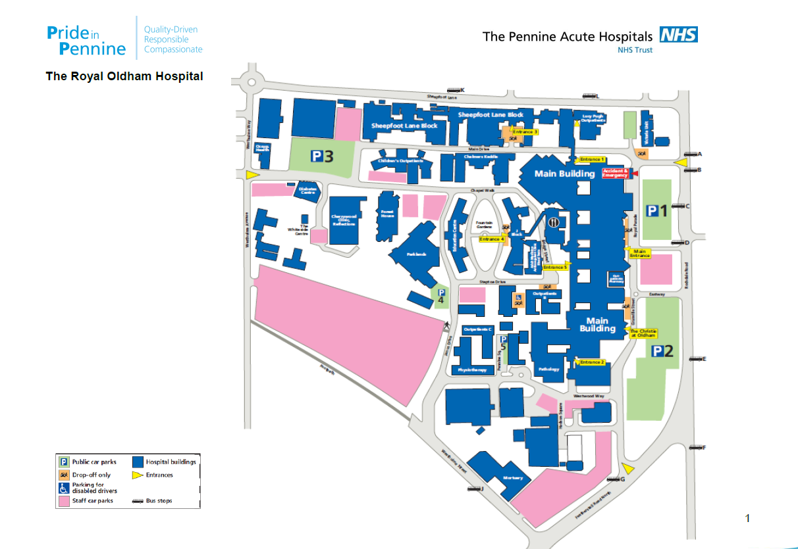

Please enter the site from the B&Q entrance (circled in green), parking is available at P3 (circled in yellow) and then the Dinwoodie Centre is circled in red.